Anti-Bullying Policy
Braddan School

Written in June 2025
Approved by Governors June 2025
Reviewed in line with Policy Review Timeline 2027

Braddan School promotes values which reject bullying behaviour and promote co—operative behaviour. Tackling bullying matters.

STATEMENT OF INTENT
Braddan School is committed to providing a supportive, caring and safe environment in which all children are free from the fear of being bullied. As a school we take bullying and its impact seriously. Bullying of any form is not tolerated in our school, whether carried out by a child or an adult.
Staff, children and parents or carers will be made aware of the school’s position on bullying. Bullying behaviour is unacceptable in any form. The school has high expectations of outstanding behaviour and we consistently challenge any behaviour that falls below this. Anyone who knows that bullying is happening is expected to tell a member of staff.
Any child who is a victim of bullying will be dealt with in a sympathetic manner. If bullying is suspected or reported, the incident will be dealt with immediately by the member of staff informed, and then discussed with the Senior Leadership Team member or Headteacher. A clear account of the incident will be recorded in the behaviour books. All staff will be informed so that close monitoring of the victim and bully can begin. Parents of both parties will be informed.

WHAT IS BULLYING
Braddan School recognises that many children and young people will experience conflict in their relationships with other children and young people. We are committed to developing empathy and the skills to manage relationships in a peaceful way that does not harm others.
The Anti-Bullying Alliance defines bullying as:
“The repetitive, intentional hurting of one person or group by another person or group, where the relationship involves an imbalance of power. Bullying can be physical, verbal or psychological. It can happen face-to-face or online.”

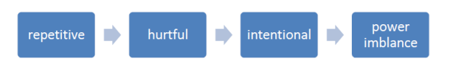
WHY IS IT IMPORTANT TO RESPOND TO BULLYING?
There is considerable evidence to show that bullying has both short term and longer-term impact on pupils. Bullying impacts on pupils’ wellbeing, can impact on attendance and become a significant barrier to learning. Bullying is associated with lower levels of school engagement and achievement both in primary and secondary schools and can lead to mental health concerns such as anxiety and depression.

BULLYING IS UNACCEPTABLE. BRADDAN SCHOOL WILL RESPOND PROMPTLY AND EFFECTIVELY TO REPORTED INCIDENTS OF BULLYING.
In our school community:
- Everybody has the right to be treated with respect
- Everybody has the right to feel safe and happy
- No-one deserves to be a target of bullying
- Pupils who bully need to learn different ways of behaving.
TYPES OF BULLYING BEHAVIOUR
Bullying can take many forms:
- Emotional – being unfriendly, excluding, tormenting, threatening behaviour
- Verbal – name calling, sarcasm, spreading rumours, teasing, use of derogatory language
- Physical – pushing, kicking, hitting, punching or any use of violence
- Extortion – demanding money/goods with threats
- Online – use of social media, messaging and calls. Misuse of associated technology e.g. photos and videos
- Racist – racial taunts, graffiti, gestures
- Sexual – unwanted physical contact, sexually abusive comments
- Homophobic or biphobic – bullying because of sexuality or perceived sexuality
- Transphobic – because of gender identity or perceived gender identity
PREVENTING BULLYING
At Braddan School we have a clear understanding that bullying, in any form, is unacceptable. We believe that preventing bullying is the responsibility of our whole school community and when there are incidents of bullying we will work together to deal with the situation and to learn from what has happened.
We do this by:
- Building a positive ethos based on respecting and celebrating all types of difference in our school.
- Having a positive ethos that all pupils, staff and parents understand.
- Promoting a clear message that bullying will not be tolerated.
- Work in school which develops empathy, social skills and emotional understanding e.g., RSE, Citizenship, social and emotional learning programmes.
- Raising awareness of online bullying through regular e-safety lessons.
- Offering training to all school staff around bullying.
REPORTING BULLYING
At Braddan School pupils are encouraged to talk to staff when they are unhappy or have concerns. Pupils in our school understand that they have a right to feel and be safe and a responsibility to support others to feel and be safe.
- It is important to identify the nature and extent of the bullying and the alleged victim’s class teacher begins the Bullying Incident Report form (see appendix 1).

- The incident should be discussed with the pupils individually by the children’s class teacher(s), recording their comments in a non-judgmental way in order to ensure that the pupil feels they are being listened to. Pupils should be reassured that all incidents of bullying are taken seriously.

- See the pupils involved together, if both parties agree. At this meeting pupils will be encouraged to:

- reflect on their behaviour and the factors that may have influenced the behaviour of others
- identify how they can resolve the current difficulties and avoid the problems recurring

- After the meeting:

- If bullying has taken place, the class teachers and Senior Leadership Team member should consider what support can be made available to the victim(s) and meet with him/her to discuss the options (buddy system, own circle of friends, school nurse, youth worker)
- The class teachers and Senior Leadership Team member should consider the sanctions the school will impose on the perpetrators
- All incidents will be recorded on a form held centrally (Appendix 2)
- Incidents of bullying will be reported to the School Governors (based on Appendix 2) so that incidents and trends can be reviewed / analysed

- The class teacher should hold a review meeting after one-week (interviewing the pupils individually before this happens). If the matter is successfully resolved by the time the review occurs, copies of the Bullying Incident Report will be placed in the Bullying Incident file. This will be retained for 2 years from the date of the incident

- If there is evidence of further bullying or provocation, the Headteacher will arrange to meet the pupils’ parents or carers to identify options to resolve the problems successfully

- Once the matter has been successfully resolved, unless there is a further occurrence of bullying, the school will not refer back to it

- If there is limited progress within an agreed time scale, then the Department of Education Sport and Culture guidance on suspensions will be followed.

RESPONDING TO BULLYING
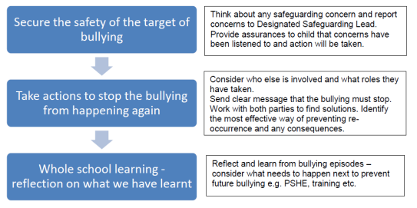
We monitor, record and review all bullying incidents to determine any patterns or trends that may require further action. See appendix 1 & 2.

PROCEDURES FOR PARENTS
If a parent has any concerns about their child, they should contact their child’s class teacher in the first instance.

FURTHER RESOURCES
This policy has links to the following policies:
School Positive Relationships and Behaviour Policy
School Safeguarding and Child Protection Policy
School RSE Policy
DESC Restraint and Handling policy

APPENDIX 1

BULLYING INCIDENT REPORT FORM

This form is to be completed by the child’s class teacher following discussion with the pupils individually. Comments should be recorded in a non-judgemental way.

Name of Pupil |  | Year
Date of Incident |  | Time of Incident
Location
Who was present
What happened? (give details of incident, use additional pages if necessary)

What was the cause or the events leading up to this incident?

Has an incident happened before involving this/these pupils? YES/NO

If yes, provide brief details

Next Steps (including pupil support/sanctions

Senior Leadership Team member signature

Appendix 2

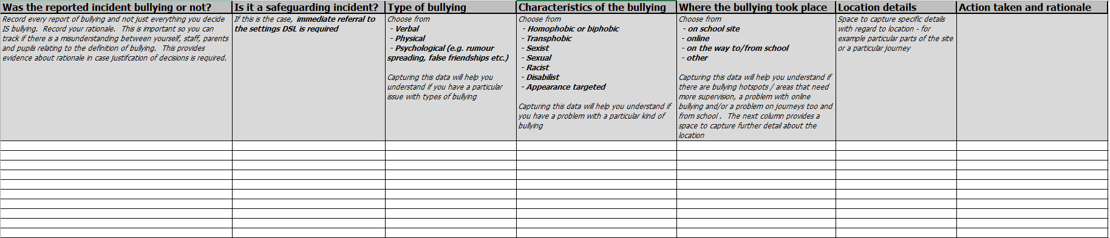

This form should be kept up to date by SENIOR LEADERSHIP TEAM and updated following all reported incidents to establish trends or patterns for follow up.

Monitoring, Evaluation and Review

This policy will be reviewed by all staff on a two-year basis or when the need arises, to assess its implementation and effectiveness. The policy will be promoted and implemented throughout the school.

