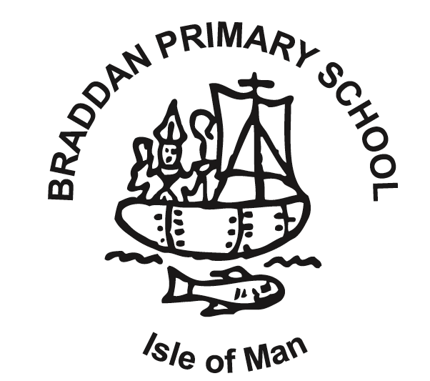

Relationships and Sex Education (RSE) Policy

This policy applies to staff, volunteers, Governors, and any visitors to the school who may be teaching any aspect of relationships or sex education.

To be read and used in conjunction with behaviour, antibullying, safeguarding and equal opportunities policies.

Links with PSHE
All aspects of education of pupils’ personal, social and health education (PSHE) will be taught using a combination of the following:
Jigsaw PSHE Programme
National Curriculum Science
ICT Pathways e-safety
Relationships and Sex Education
IOM RE Syllabus
(Sept 2022 – New IOM guidance and curriculum support is now available on TEAMS)

Aim
The purpose of this policy is to clarify the content of the RSE curriculum and delivery at Braddan School.
It complies with the Department for Education, Sport and Culture legal and policy requirements.
A copy is available in school and on TEAMS for staff. Parents are welcome to view the policy. All Governors have access to this policy.

This policy has been written in consultation with parents and Governors of Braddan School.

Relationships Education
Relationships Education teaches about families and people who care for pupils, caring friendships, respectful relationships, online relationships and being safe. It teaches pupils how to recognise and build healthy relationships, how relationships can affect health & wellbeing (including mental health) and about how to build healthy online relationships.

Sex Education
Sex Education comprises statutory education in the Science National Curriculum:
Key Stage 1
1. b) that animals including humans, move, feed, grow, use their senses and reproduce
2. a) to recognise and compare the main external parts of the bodies of humans
f) that humans and animals can produce offspring and these grow into adults
4. a) to recognise similarities and differences between themselves and others and treat others with sensitivity

Key Stage 2
1. a) that the life processes common to humans and other animals include nutrition, growth and reproduction
2. f) about the main stages of the human life cycle

In addition, pupils will learn age – appropriate sex education to prepare them for adolescence. This will be tailored to the physical and emotional maturity of the pupils and so will not have a set age/year group in this policy. Sex education is taught within the context of relationships.

Parent/Carer Roles
Parents and Carers are the main educators for children learning about relationships and sex. Braddan School provides RSE to support parents and carers in their responsibility. Parents and carers have the right to withdraw their children from the aspects of sex education that is not covered by the Science curriculum. We do encourage all children to take part, and where a parent seeks to withdraw their child, a face to face discussion should be held in order to explain any misconceptions or concerns the parent may have.

Relationships Curriculum
Between Reception and Year 6, pupils will be taught the following:

Families and people who care for me:
Pupils should know
- that families are important for children growing up because they can give love, security and stability.
- the characteristics of healthy family life, commitment to each other, including in times of difficulty, protection and care for children and other family members, the importance of spending time together and sharing each other’s lives.
- that others’ families, either in school or in the wider world, sometimes look different from their family, but that they should respect those differences and know that other children’s families are also characterised by love and care for them.
- that stable, caring relationships, which may be of different types, are at the heart of happy families, and are important for children’s security as they grow up.
- that marriage and civil partnership represents a formal and legally recognised commitment of two people to each other, which is intended to be lifelong.
- how to recognise if family relationships are making them feel unhappy or unsafe, and how to seek help or advice from others if needed.

Caring Friendships
Pupils should know:
- how important friendships are in making us feel happy and secure, and how people choose and make friends.
- the characteristics of friendships, including mutual respect, truthfulness, trustworthiness, loyalty, trust, sharing interests and experiences and support with problems and difficulties.
- that healthy friendships are positive and welcoming towards others, and do not make others feel lonely or excluded.
- that most friendships have ups and downs, and that these can often be worked through so that the friendship is repaired or even strengthened, and that resorting to violence is never right.
- how to recognise who to trust and who not to trust, how to judge when a friendship is making them feel unhappy or uncomfortable, how to manage these situations and how to seek help or advice from others, if needed.

Respectful Relationships
Pupils should know
- the importance of respecting others, even when they are very different from them (for example, physically, in character, personality or backgrounds), or make different choices or have different preferences or beliefs.
- the conventions of courtesy and manners.
- the importance of self-respect and how this links to their own happiness.
- that in school and in wider society they can expect to be treated with respect by others, and that in turn they should show due respect to others, including those in positions of authority.
- about different types of bullying (including cyberbullying), the impact of bullying, responsibilities of bystanders (primarily reporting bullying to an adult) and how to get help.
- what a stereotype is, and how stereotypes can be unfair, negative or destructive.
- the importance of permission-seeking and giving in relationships with friends, peers and adults.

Online relationships
Pupils should know
- that people sometimes behave differently online, including by pretending to be someone they are not.
- that the same principles apply to online relationships as to face-to-face relationships, including the importance of respect for others online including when we are anonymous.
- the rules and principles for keeping safe online, how to recognise risks, harmful content and contact, and how to report them.
- how to critically consider their online friendships and sources of information including awareness of the risks associated with people they have never met.
- how information and data is shared and used online.

Being Safe
Pupils should know
- what sorts of boundaries are appropriate in friendships with peers and others (including in a digital context).
- about the concept of privacy and the implications of it for both children and adults; including that it is not always right to keep secrets if they relate to being safe.
- that each person’s body belongs to them, and the differences between appropriate and inappropriate or unsafe physical, and other, contact.
- how to respond safely and appropriately to adults they may encounter who they do not know.
- how to ask for advice or help for self and for others, and to keep trying until they are heard, including having the vocabulary and confidence to report concerns or abuse.
- where to get advice from e.g. family, school and/or other sources.

Learning
Braddan School’s teaching staff will lead the learning, with support from the DESC if required. Learning can take place as stand-alone lessons, as part of a topic, through story /circle time and through the daily life of the school community.

Teaching Sequence
Teaching staff will be following the Jigsaw PSHE curriculum, which includes the RSE aspect, along with the National Curriculum for Science.
The Jigsaw Programme links closely and easily with the IOM Six Rs Curriculum.
If there is one pupil or a small group who is identified as needing some earlier education on periods or puberty, this can take place after consultation with parents or carers.
All correct names for body parts will be taught.

Answering tricky questions
Pupils will often ask their teachers or other adults questions about sex or sexuality which go beyond what is set out for RSE. Children of the same age may be developmentally at different stages, leading to differing types of questions or behaviours. Staff members should take account of those differences (including SEN or disabilities) and consider whether a small group or one-to-one discussion might be more appropriate to answer that question. Staff should refer to SMT if they have any concerns.
Pupils whose questions go unanswered may turn to inappropriate sources of information. All questions should be addressed if possible.

LGBTQ+
All teaching on relationships will be LGBTQ-inclusive. Staff will not teach one sort of relationship as preferable over another. Instead they will teach pupils about what makes a healthy relationship.

Monitoring and Impact of the Policy
The staff will monitor the impact of the policy on the attitudes and understanding of the pupils.
The finding of the process will be shared with Governors.

Equal Opportunities
Braddan School is committed to an Inclusive policy of equal opportunity for all pupils. All pupils who attend any school are entitled to a Relationships and Sex Education regardless of age, sex, race, disability, religion or belief, gender reassignment, pregnancy or maternity, marriage or civil partnership, or sexual orientation (collectively known as the protected characteristics).

Braddan School also makes reasonable adjustments to alleviate disadvantage and is mindful of its obligations towards pupils with additional needs under the Education Act. All lessons are planned with these factors in mind.

April 2019
Next Review Summer term 2020
Minor adjustments made Sept 22

